Review materials on Gilgamesh and the Two Noah stories, film comparisons and view the Noah Veggie tales in Assignments. Write a two to three-page review using the rubric below to describe the question of sources and themes
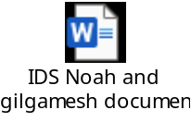
Link to Video : https://youtu.be/AkT38zMqFvY
